PRESS RELEASE
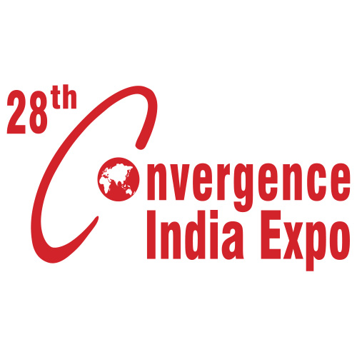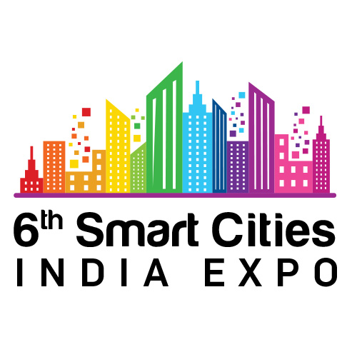
Industry Leaders and City Administrators from Smart Cities to discuss Progress & Roadmap at
6th Smart Cities India & 28th Convergence India 2021 expo

- The 3-day Expo & Conference to showcase strides made by Indian Smart Cities in improving the quality of life of citizens and efficiency in battling the pandemic

- Special Events at the Expo include Smart Cities Conclave and City Leader’s Conclave, which will see various Smart City CEOs and Mayors delivering critical analysis & reflections on making cities greener, more sustainable and climate-resilient

- Industry’s most prestigious Smart Cities India Awards will felicitate and encourage entities spearheading urban and rural transformation.
New Delhi, 17th March 2021: The 6th Smart Cities India expo – India's largest event for sustainable cities – will bring together a large number of city leaders, who are entrusted with creating sustainable urban spaces across the nation. City Administrators from various Indian Smart Cities, including Bhopal, Jabalpur, Gwalior, Ahmedabad, Ajmer, Nagpur, Amravati, Varanasi, Srinagar, Faridabad, Sagar, Kota, Chandigarh, and many more will convene at the 6th Smart Cities India 2021 expo for multi-layered discussions on how India's 100 Smart Cities hit the ground running during the COVID-19 pandemic; learning along the way, and leading by example.
Scheduled to be held from 24-26 March 2021 at Pragati Maidan, New Delhi; India’s largest technology and infrastructure event – the 28th Convergence India & 6th Smart Cities India 2021 expo – is all set to be the first meaningful in-person event in the new normal, with a mission to accelerate nation building and unlock growth & opportunities. The expo will feature key verticals that constitute the smart city framework, including Buildings, Clean technologies, Solar, Transport, Water, etc.
The 50+ Conference sessions through the course of 3 days will include pivotal discussions on a spectrum of topics to make cities greener, happier, healthier, climate-resilient and more sustainable. Key deliberations will include sessions on Smart Cities: Building Cities for People; The Future of Mobility in India; Water Security; Making Affordable, Sustainable and Innovative Housing a Reality in Cities; City Leaders Conclave; Cities Approach towards Urban Environment, Climate, Waste, and Mobility; and many more. One of the highlights of the expo will be the Smart Cities India Awards – a unique platform designed to felicitate, recognize and encourage individuals, policy makers, companies, municipalities, government bodies and associations to illuminate the work done in both urban and rural sectors.
Joining hands with organizers, Exhibitions India Group and India Trade Promotion Organization, as Knowledge Partner is market leader KPMG. Mr. Puneet Narang, Partner, Urban Transformation and Major Projects Advisory, IGH, KPMG in India, said, “While the pandemic exposed the extent to which our cities and other human settlements are vulnerable to such disruptions, it also allowed our cities to innovate on the back of centrally sponsored schemes such as Smart Cities Mission. Notably, the use of some of the Integrated Command and Control Centres – as ‘war rooms’ for combating the pandemic for contact tracing, identification & isolation, and yet keeping the basic and essential services optimally operational is a fine example of innovation to overcome adverse conditions.
This three day event provides an opportunity to hear from and engage with key stakeholders like the Govt of India, local administrations of Smart Cities, industry leaders, and deliberate on challenges faced, emerging trends and most importantly – solutions that governments and private sector can collaborate on, across a complex set of urban interconnected issues in cities ranging from mobility, water and sanitation, housing, public safety as well as repurposing and innovation required around finance, technology and execution. We hope to support the longer objective of embedding intelligent & ‘smart’ design into core infrastructure & services (roads, water, sanitation, housing, waste management), while also fostering strengthened delivery through improved adoption of digital and information enabled means. We hope this helps improve community well-being and citizen participation, helping us build a smarter, digital, inclusive and resilient new India,” he added.
Welcoming all industry stakeholders to the expo, Ms. Chandrika Behl, Managing Director, Exhibitions India Group, said, “This year’s expo holds considerable significance for the industry, and the nation at large. Throughout the ‘New Normal,’ we have witnessed an ever-increasing integration of technologies into our day-to-day lives. Digital transformations are driving development and progress across all industries and spheres of life, and will be instrumental in writing the Indian growth story. As we organize the latest edition of the expo, we believe that our carefully-curated platform will be a catalyst in India’s emergence on the global stage as a Knowledge Leader.”
About 28th Convergence India & 6th Smart Cities India 2021 expo
The 28th Convergence India & 6th Smart Cities India expo, scheduled from 24-26 March 2021, at Pragati Maidan, New Delhi, is organised by Exhibitions India Group (EIG) and the India Trade Promotion Organisation (ITPO). Convergence India is at the forefront of India’s digital revolution, while Smart Cities India expo reflects India’s emerging modernization and development landscape. The combination of these two leading expos, supporting India’s Digital & Smart Cities Missions, is supported by various Government of India Ministries & PSUs. The event attracts a large turnout of qualified visitors & delegates from government departments and private organisations.

Strip of Leading Speakers

For Further Information, Contact:
Ms. Aishwarya Sinha | E: aishwaryas@eigroup.in | M: +91 8130 316 306
Visit: https://www.convergenceindia.org/ & https://www.smartcitiesindia.com/
For Media Registration, visit:

To view the full list of Speakers, visit: www.eiexpolive.com/speakers.aspx

Get Social with Us:
Facebook: https://www.facebook.com/smartcityindia/
LinkedIn: https://www.linkedin.com/company/smart-cities-india/
Twitter: https://twitter.com/smartcitiesind
YouTube: https://www.youtube.com/watch?v=AwOW80bnqbg&t=1s

