PRESS RELEASE
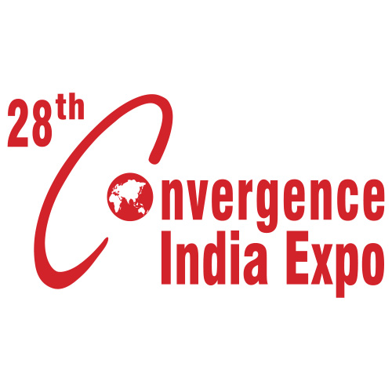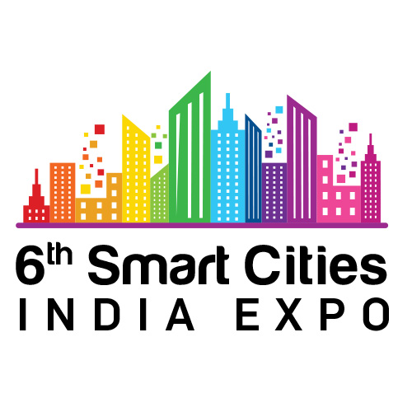
To Build a Digital & Smart India, Industry Leaders & City Administrators Converge at the 6th Smart Cities India &
28th Convergence India 2021 expo
- From EVs and financial services to knowledge papers and smart consumer electronics – everything towards creating a connected and sustainability-oriented India will be on display at the expo

- 50 high-level conference sessions at India’s largest Tech & Infra expo will focus on building a Digital & Smart India

New Delhi, 24th March 2021: After a year of virtual events, the 28th Convergence India & 6th Smart Cities India expo opens its doors to the nation’s largest in-person B2B technology and infrastructure event from 24-26 March 2021, at Pragati Maidan, New Delhi.

While digital communication has been our lifeline this past year, this time has also demonstrated the significance of personal, face-to-face networking. It is now time to accelerate nation building at the industry’s premier Expo & Conference, organised by Exhibitions India Group (EIG) and the India Trade Promotion Organisation (ITPO).

The eve of the 2021-22 FY is the perfect time to resume business networking, and demonstrate a show of strength and optimism going into the next financial year – with the expo being the first meaningful live event since the authorities permitted the resumption of trade fairs.
Convergence India is at the forefront of India’s digital revolution, while the Smart Cities India expo is a reflection of India’s emerging modernization and development landscape. The combination of these two leading expos, supporting India’s Digital & Smart Cities Missions, delivers an event that focuses on unlocking new opportunities and reviving economic growth.
Key Exhibitor Sectors:
- Telecom & Broadcast, OTT, Satcom, IoT, FinTech, Blockchain, Cybersecurity, AI, Big Data & Analytics, Embedded Technology & Digital Gaming
- Integrated Command Control Centres (ICCCs), e-Governance, Communication systems, Data storage and management, Digital Twin & Innovative urban planning practices
- Green buildings, solar, energy, transport, clean environment and water, for optimising resources and making cities smart and sustainable

2021 Expo Highlights:

- 500 Participating Brands
- 20,000 sqm Exhibition Area
- 50 Conference Sessions
- 250 Conference Speakers
- 60 International Exhibitors Connecting Virtually

Special Showcases & Events:
- The Startup Pavilion, supported by ‘Startup India,’ will feature over 35 startups across various segments of ICT & Smart Cities technologies, bringing to light new innovations this year, and promoting the Government of India’s initiative of an ‘Aatmanirbhar Bharat.’ This year’s edition will feature a ‘Start up Pitch’ competition being sponsored by IC IIT Patna across various sectors, with incubation opportunities and other rewards for the best 3 startups.
- The Smart City India (SCI) Awards, including FinTech India Awards, scheduled for March 26^{th,} 2021, is a unique platform designed to felicitate, recognize and encourage individuals, policy makers, companies, municipalities, government bodies and associations to illuminate the work done across both urban and rural sectors.
- Hybrid Expo & Phygital Conference: For the first time, the expo has adopted a hybrid format, with both physical and digital formats being held simultaneously. Participants can connect with 60 international exhibitors at the Virtual expo; with interactive features including Virtual Booths, Exhibitor Meetings, Exhibitor Live Chats, Video Calls & Virtual Rooms, Exhibitor Product Marketplace, Exhibitor Lead Capture, and more. Our Phygital Conference will see 50 conference sessions – both on-ground and virtually – taking place concurrently across a vast range of topics.
Some eminent speakers at the expo include Shri Jibesh Kumar, Hon’ble Minister, Dept. of IT, Govt. of Bihar; Shri Durga Shanker Mishra, Secretary, Ministry of Housing & Urban Affairs, Govt. of India; H. E. Andre Aranha Correa do Lago, Ambassador, Embassy of Brazil in India; Shri Rajeev Talwar, CEO, DLF Developers Ltd.; Shri P. D. Vaghela, Chairman, TRAI; Ms. Gauri Singh, Deputy Director General, International Renewable Energy Agency; Shri Rajiv Ranjan Mishra, Director General, National Mission for Clean Ganga; Shri Dharmendra, Chairperson & Member, NDMC; Prof. Ashutosh Sharma, Secretary, Ministry of Science & Technology, Govt. of India; Shri Kunal Kumar, Joint Secretary, Smart Cities Mission, Ministry of Housing and Urban Affairs; Shri Deepak Bagla, Managing Director & CEO, Invest India, and many more.
The organizers EIG and ITPO have channelled all efforts to curate and execute a successful expo to put the industry back on the path of growth and opportunity. The wellbeing of all exhibitors, buyers, visitors and partners being the topmost priority, all regulations and SOPs – including contactless registration, regular sanitization, real-time capacity monitoring, medical services and appropriate social distancing – will be strictly adhered to.

Shri Rajesh Agrawal, Executive Director, ITPO, expressed optimism on behalf of the country’s apex trade promotion body, “After a year-long hiatus from exhibitions, we are pleased to welcome our long-term partner Exhibitions India Group back to Pragati Maidan, with India’s largest technology and infrastructure expo. After a tumultuous year for businesses across all verticals of trade, it’s now time to accelerate nation building, and contribute to the growth of our economy by showcasing India’s commercial might. As Pragati Maidan is being redeveloped into a world-class Integrated Exhibition-cum-Convention Centre (IECC) – a modern, up-to- date centre to host global conferences and exhibitions – I am delighted to invite all industry people to network safely and successfully at the 28th Convergence India and 6th Smart Cities India 2021 expo in the new halls.”

Welcoming all industry stakeholders to the expo, Ms. Chandrika Behl, Managing Director, Exhibitions India Group, said, “This year’s expo holds considerable significance for the industry, and the nation at large. Throughout the ‘New Normal,’ we have witnessed an ever-increasing integration of technologies into our day-to-day lives. Digital transformations are driving development and progress across all industries and spheres of life, and will be instrumental in writing the Indian growth story. As we organize the latest edition of the expo, we believe that our carefully-curated platform will be a catalyst in India’s emergence on the global stage as a Knowledge Leader.”
About Exhibitions India Group
Exhibitions India Group (EIG) is a trade promotion organization creating opportunities for investments, joint ventures and technology transfers. EIG acts as an interface between businesses, government, academia, society, media, etc. EIG has been in existence since 1987, and is committed to providing satisfaction to its customers by organizing quality and focused international trade shows through exceptional services, employee involvement, market intelligence and continual improvement. For more information, please visit: http://www.exhibitionsindia.com/
For further information, please contact:
Aishwarya Sinha | Mob: +91 81303 16306 | Email: aishwaryas@eigroup.in
To know more, visit:
https://www.convergenceindia.org/ & https://www.smartcitiesindia.com/
Register for the Virtual expo & Conference: https://www.convergenceindia.org/eiexpolive.aspx

