PRESS RELEASE
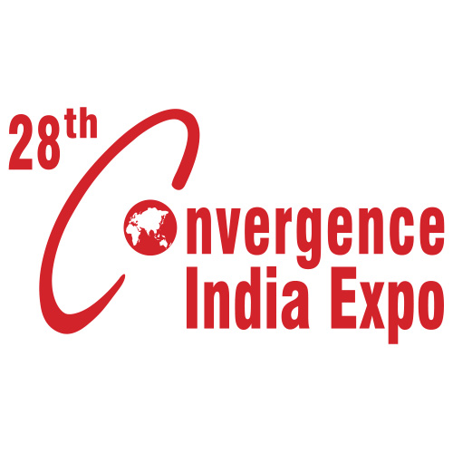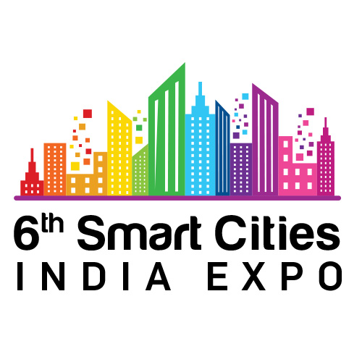

Cutting Edge Solutions & Technologies on Display at the
28th Convergence India & 6th Smart Cities India expo

- From EVs and financial services to knowledge papers and smart consumer electronics – everything towards creating a Digital and Smart India will be on display at the expo

- 30 high-level conference sessions at India’s largest Tech & Infra expo will focus on building a Digital & Smart India

New Delhi, 15th March 2021: India’s largest technology and infrastructure expo – the 28th Convergence India & 6th Smart Cities India 2021 expo – welcomes industry pioneers to join the deliberations for accelerating nation building, unlocking growth, and exploring new business opportunities.
Slated to be the first meaningful, in-person B2B expo to take place since the pandemic changed the nature of our world in 2020, India’s largest tech & infra expo will be joined by leaders such as Piaggio Vehicles Pvt. Ltd., Mazars, State Bank of India, Hyundai Motor India Limited, LG Electronics India Limited, and many more.
Experts from these industry pioneers will showcase cutting-edge technologies and solutions at the 28th Convergence India & 6th Smart Cities India expo. The Expo & Conference will deliberate on path-breaking initiatives, and encourage sustainable solutions for India’s socio-economic growth. With a vision to Build a Digital & Smart India, the expo will promote various initiatives by stakeholders to create a sustainable future for our citizens.
Stakeholders will network in person once again at the expo and discuss a variety of topics, ranging from Digital Transformation, Intelligent Home Automation, innovations in the FinTech space, Smart Mobility, Road Safety, Environment Protection, Clean & Healthy India, Cloud Computing and emerging trends & technologies in the digital arena.
A pioneer of 3-wheeler goods transportation in India, Piaggio has revolutionized the 3-wheeler cargo segment in the country, and continues to set global standards across various arenas of service. Empowered by decades of knowledge in the Indian market, Piaggio has under its umbrella state-of-the-art products providing an improved quality of life to millions across India. Piaggio will be displaying on the expo floor two of its latest 3-wheeler EV models- Ape E-City and Ape E-Xtra. The 2021 Ape e-City is intended for the passenger segment, while the Ape e-Xtra is the company's first electric three-wheeler for the cargo segment.
Mazars is an internationally integrated partnership, specializing in audit, accountancy, advisory, tax and legal services. In India, Mazars has a national presence with over 1,000 professionals offering in-depth experience in sectors like Energy, Telecom, BFSI, Automobiles, Technology, Real Estate, Shipping, Services, Manufacturing and Retail. Mazars in India has partnered as a ‘Thought Leader’ and will be launching its thought leadership report, Where’s my cloud?, at the expo. The paper aims to highlight the growth of cloud computing and touch upon core focal areas that companies must consider when designing their own cloud adoption strategy – both within and after migration.
State Bank of India- the country’s largest commercial bank in terms of assets, deposits, branches, customers, and employees- will place a spotlight on their flagship digital and lifestyle platform YONO app. Accelerating the digital agenda, 1.5 million new accounts were opened through YONO in the quarter ending December 2020. SBI YONO, which has also emerged as a global name with success across international markets, will be centrestage at the expo.
With Hyundai’s unwavering dedication towards the global brand vision of ‘Progress for Humanity,’ the leading automotive brand will showcase their initiatives as ‘Road Safety Partner’ at the expo. Under the aegis of the global vision, Hyundai’s Road Safety Campaign ‘BeTheBetterGuy’ works towards emphasizing the importance of Safe and Responsible driving; spearheading the Safe Move Campaign to become a social movement with people’s participation for a better, healthier tomorrow. Exhibiting new EV models at the expo, Hyundai is committed to encouraging significant behavioural change amongst masses with road safety, as well as health & hygiene.
Speaking at the commencement of the expo, Mr. Puneet Anand, AVP & Group Head, Corporate Affairs, HMIL said, “We are pleased to associate as ‘Road Safety’ partner with India’s leading Technology & Infrastructure Expo. Under our global brand vision, ‘Progress for Humanity’, HMIL is committed to create amicable ecosystem to realize dreams of mankind and construct future role models that can drive social change. ‘Safe Move’– Road safety initiative is aimed to enhance awareness and understanding of road safety rules to bring significant behavioural change among masses, thereby envisaging the creation of institutions that have a widespread impact on future generations towards importance of road safety.”
Finally, joining the expo is LG Electronics India Limited (LGEIL)- a leading brand in consumer electronics, home appliances, HVAC, IT hardware and mobile communications space. Committed to delivering innovative and intelligent products, LGEIL is an acknowledged trendsetter within the industry, and a conscious market leader with a drive for sustainable solutions. LGEIL's manufacturing unit at Greater Noida is one of the most eco-friendly units among all LG manufacturing plants in the world, as part of the company’s drive to cultivate environment-friendly solutions.
Ms. Chandrika Behl, Managing Director, Exhibitions India Group, welcomed the new partners, “Our forum is committed to being a catalyst in India’s inevitable growth story, and promoting smart and sustainable choices as leading priorities in modern India. We have curated a platform for leaders from across industries to inspire and share best practices. We are optimistic about India’s future as a knowledge leader on the global stage, and on the path to achieving that, we look forward to enduring, synergetic relationships with our esteemed partners.”

About 28th Convergence India & 6th Smart Cities India 2021 expo
The 28th Convergence India & 6th Smart Cities India expo, scheduled from 24-26 March 2021, at Pragati Maidan, New Delhi, is organised by Exhibitions India Group (EIG) and the India Trade Promotion Organisation (ITPO). Convergence India is at the forefront of India’s digital revolution, while Smart Cities India expo reflects India’s emerging modernization and development landscape. The combination of these two leading expos, supporting India’s Digital & Smart Cities Missions, is supported by various Government of India Ministries & PSUs. The event attracts a large turnout of qualified visitors & delegates from government departments and private organisations.

For Further Information, Contact:
Ms. Aishwarya Sinha E: aishwaryas@eigroup.in | M: +91 8130 316 306
Visit: www.eiexpolive.com
To view full list of Speakers, visit: www.eiexpolive.com/speakers.aspx

Get Social with Us:
Facebook: https://www.facebook.com/smartcityindia/
LinkedIn: https://www.linkedin.com/company/smart-cities-india/
Twitter: https://twitter.com/smartcitiesind
YouTube: https://www.youtube.com/watch?v=AwOW80bnqbg&t=1s

